**INDIAN TEST TEAM SELECTION**

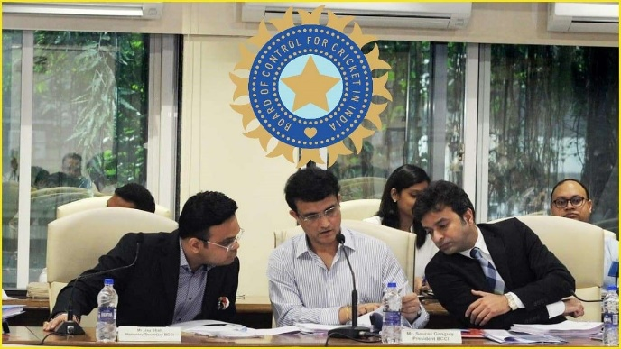

The selectors sit in a round table. To keep it fair they do not read by player name. They provide various queries to select the team based on their past performances.

* **BATSMAN** 

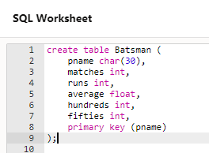

* Selector 1: We need the best batsman who has most runs in test matches.

Query:

*select pname from Batsman*

*where runs = (*

*select max(runs) from Batsman);*

Output : Virat Kohli

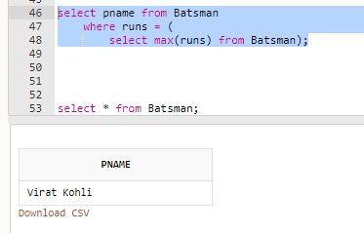

* Selector 2: Best batting average in test matches

Query:

*select pname from Batsman*

*where average = (*

*select max(average) from Batsman);*

Output : Shreyas Iyer

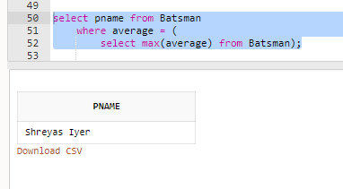

* Selector 3: Batsman who can play long innings (i.e. scored most hundreds)

Output: Virat Kohli. But, he is already selected. So, we will find second max.

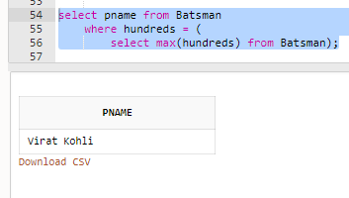

Query:

*select pname from Batsman*

*where hundreds = (*

*select max(hundreds) from Batsman*

*where hundreds not in*

*(select max(hundreds) from Batsman));*

Output : Cheteshwar Pujara

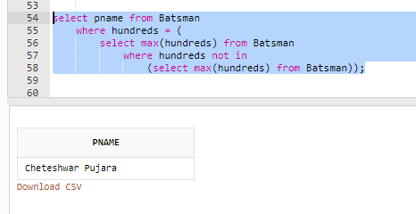

Selector 4: Batsman with good consistency (i.e. has most number of fifties)

Query:

*select pname from Batsman*

*where fifties = (*

*select max(fifties) from Batsman*

*where pname <> 'Virat Kohli' and pname <> 'Cheteshwar Pujara');*

Output: Ajinkya Rahane

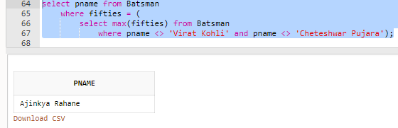

* **BOWLER**  

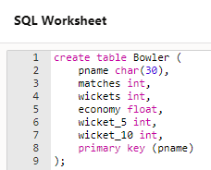

* Selector 1: We need an experienced bowler (a bowler with most no of matches)

Query:

*select pname from Bowler*

*where matches = (*

*select max(matches) from Bowler);*

Output: Ishant Sharma

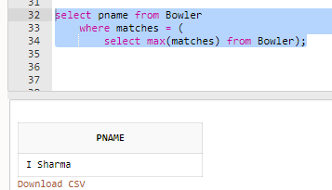

* Selector 2: We need a bowler with max no of wickets

Query:

*select pname from Bowler*

*where wickets = (*

*select max(wickets) from Bowler);*

Output: R. Ashwin

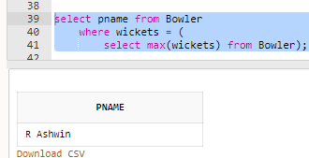

* Selector 3: Most economical bowler

Query:

*select pname from Bowler*

*where economy = (*

*select min(economy) from Bowler);*

Output: J. Bumrah

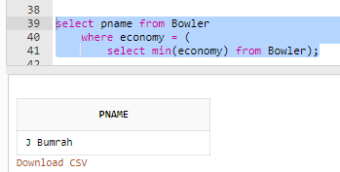

* Selector 4: Bowler(s) with more 5 wicket haul

Query:

*select pname from Bowler*

*where wicket_5 = (*

*select min(wicket_5) from Bowler);*

Output: We get 3 names : Amit Mishra, M. Siraj and Shardul

Thakur but our capacity is just to take 2 more bowlers.

Solution : So, we check the next parameter only for these 3 bowlers.

Query:

*select pname,wickets from bowler*

*where pname in (*

*select pname from Bowler*

*where wicket_5 = (*

*select min(wicket_5) from Bowler));*

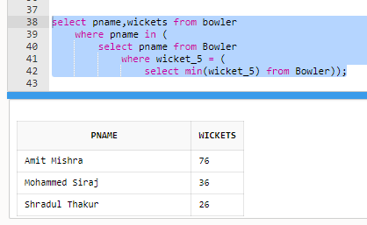

Output: Amit Mishra and M. Siraj (S.Thakur can be taken as extras)

* **Wicket Keeper**
* Selector 1: Keeper with maximum number of catches

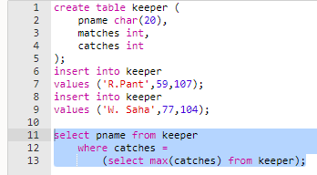

Output: R. Pant

NOTE: Since we have only 1 keeper ideally in playing XI, one keeper will go to extras. It now depends on the selector’s decision whether to give more preference to experience or number of catches.

* Selector 2: Keeper who is more experienced

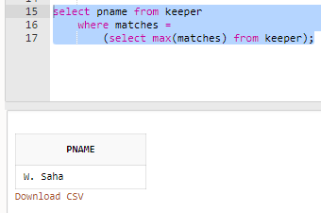

Output: W. Saha (Might go to extras)

* **All rounder**

Ravindra Jadeja